Objective : To achieve the following pattern

|  |  |
| --- | --- |
| First time switch pressed | 1 flash |
| Second time switch pressed | 2 flashes |
| Third time switch pressed | 3 flashes |
| Fourth time switch pressed | 4 flashes |
| Fifth time switch pressed | 1 flash |
| Sixth time switch pressed | 2 flashes |

(& so on, repeat on 4 multiples)

*Circuit*

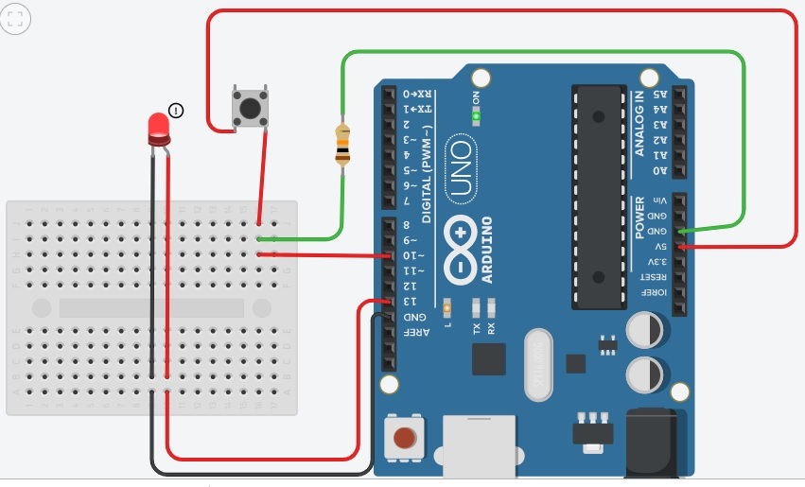

*Code:*

void setup()

{

pinMode(13, OUTPUT);

pinMode(10, INPUT);

}

int count=0;

void loop()

{

if(digitalRead(10)==1)

{

for(int i=count;i>=0;i--)

{

digitalWrite(13, HIGH);

delay(200);

digitalWrite(13, LOW);

delay(200);

}

waiting:

if(digitalRead(10)==0)

{

if(count==3)

count=0;

else

count++;

}

else

goto waiting;

}

}